Game Design Document

Armory Practice

Shrey Khetan - E21CSEU0025

**Table of Contents**

**TABLE OF CONTENTS ................................................................................................................................... 2**

**I. GAME OVERVIEW ..................................................................................................................................... 3**

A. EXECUTIVE SUMMARY ............................................................................................................................ 3

B. STORYLINE …….. ........................................................................................................................................ 3

**II. CORE GAMEPLAY ..................................................................................................................................... 3**

A. MAIN GAME VIEW ...................................................................................................................................... 3

B. CORE PLAYER ACTIVITY ........................................................................................................................... 3

C. GAME CONTROLS ........................................................................................................................................ 3

*D.* IN-GAME GUI ................................................................................................................................................. 3

**III. CONTEXTUAL GAMEPLAY ................................................................................................................,,.. 4**

A. GAME SHELL FUNCTIONS ......................................................................................................................... 4

B. GAME FLOW DIAGRAM .............................................................................................................................. 4

C. GAME MECHANICS ...................................................................................................................................... 4

D. MULTIPLAYER MECHANICS ..................................................................................................................... 4

E. SPECIAL FEATURES ..................................................................................................................................... 4

**IV. GAME ELEMENTS ................................................................................................................................…. 5**

A. CHARACTERS ................................................................................................................................................ 5

*B.* LEVEL / MISSION / AREA DESIGNS .......................................................................................................... 5

C. OBJECTS ………............................................................................................................................................. 13

D. INTRO SCENE ................................................................................................................................................ 13

E. MENU ............................................................................................................................................................... 14

F. HOW TO PLAY ................................................................................................................................................ 14

G. END SCREEN .................................................................................................................................................. 14

**V. SOUND ............................................................................................................................................................. 14**

A. MUSIC .............................................................................................................................................................. 14

B. SOUND EFFECTS ........................................................................................................................................... 14

**VI. APPENDIX A: GAMEFLOW DIAGRAM ............................................................................................... 15**

1. **GAME OVERVIEW**
2. EXECUTIVE SUMMARY   
   The VR armory practice project caters to a broad audience, designed for general enthusiasts and individuals exploring virtual reality for the first time. It serves as an introductory experience, providing users with a simplified yet engaging platform for basic armory practice with virtual weapons.
3. STORYLINE  
   Although the project does not include a complex narrative, it deliberately opts for a streamlined approach to focus on the immersive and interactive aspects of armory practice. This choice aims to enhance user engagement without the complexities of a detailed storyline.
4. **CORE GAMEPLAY**
5. MAIN GAME VIEW   
   Users find themselves in an interactive environment featuring essential armory elements: a pistol, sword, shield, and training dummies. This environment acts as the canvas for users to explore and practice various armory techniques.
6. CORE PLAYER ACTIVITY   
   The heart of the gameplay lies in the dynamic interaction between the user and the virtual armory. The pistol is controlled through shooting gestures, while the sword and shield respond to intricate hand movements. Training dummies provide visual feedback by realistically falling when struck, creating a responsive and immersive training experience.
7. GAME CONTROLS  
   Leveraging the capabilities of Virtual Reality controllers, the game employs intuitive controls. Shooting gestures emulate firearm use, adding a layer of realism, while hand movements seamlessly control the sword and shield. This approach enhances the user's sense of presence within the virtual armory.
8. IN-GAME GUI  
   To maintain a clean and straightforward user interface, the project intentionally avoids complex in-game graphical user interface (GUI) elements. This design choice prioritizes an immersive experience without unnecessary distractions.

1. **CONTEXTUAL GAMEPLAY**
2. GAME SHELL FUNCTIONS   
   Foundational game shell functions are incorporated to facilitate a seamless and user-friendly armory practice experience. These functions lay the groundwork for the core mechanics and interactions within the virtual environment.
3. GAME FLOW DIAGRAM  
   A comprehensive visual representation of the game's flow is provided through a detailed game flow diagram. This diagram serves as a reference, outlining key interactions, transitions, and the overall structure of the armory practice experience.  
     
   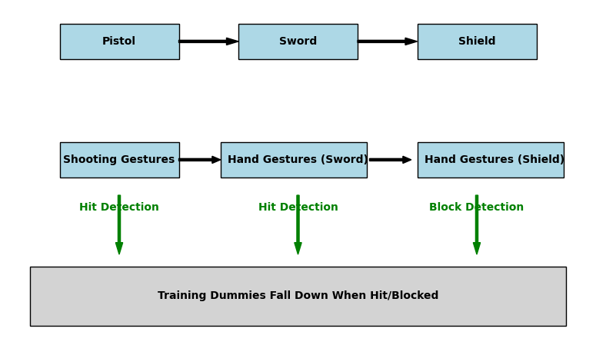
4. GAME MECHANICS  
   Fundamental game mechanics govern interactions with weapons and training dummies. These mechanics are carefully designed to strike a balance between realism and accessibility, ensuring an engaging and enjoyable learning curve for users.
5. MULTIPLAYER MECHANICS  
   While the current iteration of the project does not include multiplayer features, the groundwork for potential multiplayer mechanics is considered for future updates. This foresight allows for scalability and the introduction of collaborative elements.
6. SPECIAL FEATURES  
   The project intentionally focuses on simplicity and accessibility, foregoing additional special features. This design decision ensures that users, especially those new to VR, can easily grasp and enjoy the basic armory practice experience.
7. **GAME ELEMENTS**
8. CHARACTERS   
   The central elements of the virtual armory include the user, interactive weapons (pistol, sword, shield), and training dummies. These elements work in harmony to create a dynamic and engaging training environment.
9. LEVEL / MISSION / AREA DESIGNS   
   The virtual armory features meticulously designed training areas that house the essential components for armory practice. The layout encourages exploration and mastery of different armory techniques.  
     
   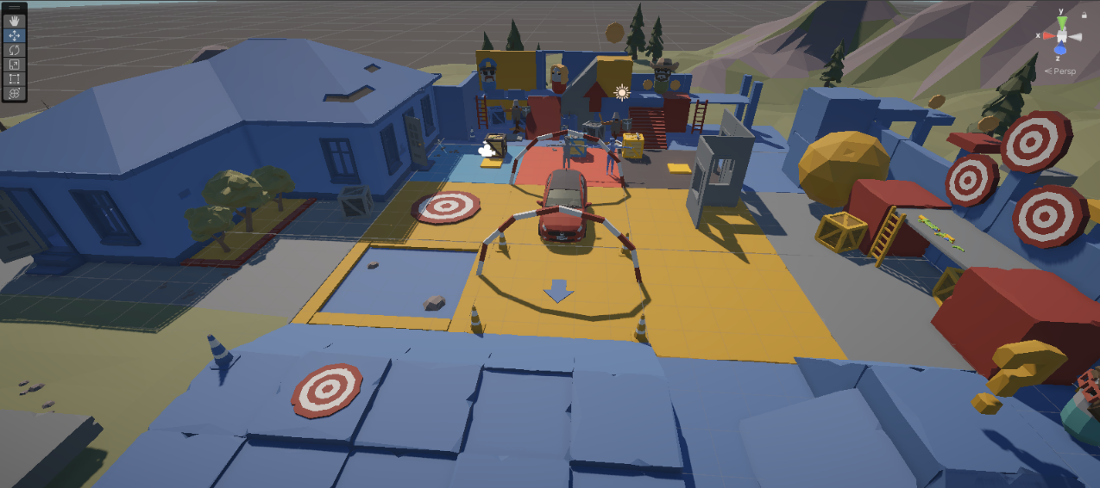  
   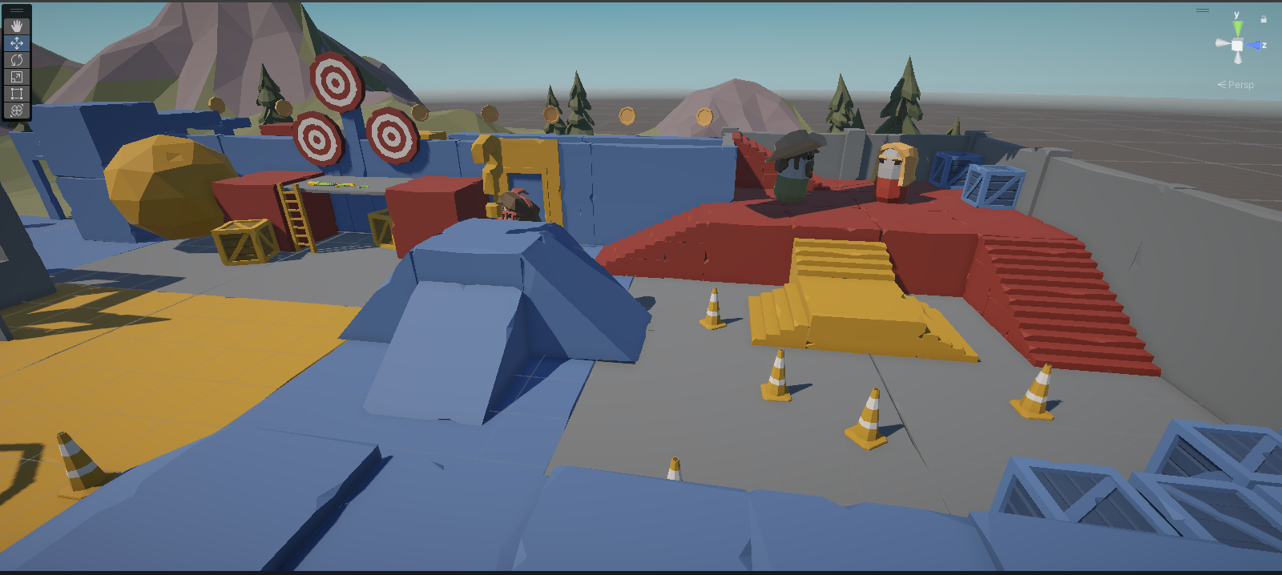
10. OBJECTS  
    Key objects within the virtual armory include weapons (pistol, sword, shield) and training dummies. These objects are thoughtfully integrated to provide users with a diverse and interactive training experience.
11. INTRO SCENE   
    The project foregoes an elaborate introductory scene, immersing users directly into the armory practice environment. This decision is aligned with the project's emphasis on simplicity and immediate user engagement.
12. **SOUND**
13. MUSIC   
    While the current version of the project does not include background music, considerations for future updates may involve the integration of thematic music to enhance the overall immersive experience.
14. SOUND EFFECTS  
    Sound effects play a crucial role in enhancing user engagement. Realistic sound effects accompany actions such as shooting, sword movements, and the reactions of training dummies, providing auditory cues that contribute to the overall realism of the armory practice.
15. **APPENDIX A: GAMEFLOW DIAGRAM**A detailed visual representation of the game's flow is provided in the appendix. This diagram serves as a valuable resource for developers, illustrating the interconnectedness of key game elements and the progression of user interactions within the armory practice environment.  
    